1) Tester l’inscription (/auth/register)
- Méthode : POST
- URL : http://127.0.0.1:5000/auth/register
- Body → raw JSON :
{
"name": "Youssef",
"email": "youssef@example.com",
"password": "1234"
}
- Réponse attendue :
{
"message": "User registered",
"2fa_secret": "<secret_2FA>"
}

2) Tester la connexion (/auth/login)
- Méthode : POST
- URL : http://127.0.0.1:5000/auth/login
- Body → raw JSON :
{
"email": "youssef@example.com",
"password": "1234"
}
- Réponse attendue :
{
"access_token": "<jwt_token>",
"two_fa_required": true
}

3️⃣ Vérification du code 2FA
POST http://127.0.0.1:5000/auth/2fa
Body (JSON) :
{
"email": "utilisateur.test@gmail.com",
"code": "123456" // remplacer par le code reçu dans l'email
}
Réponse attendue :
{
"message": "2FA passed",
"access_token": "<JWT ici>"
}

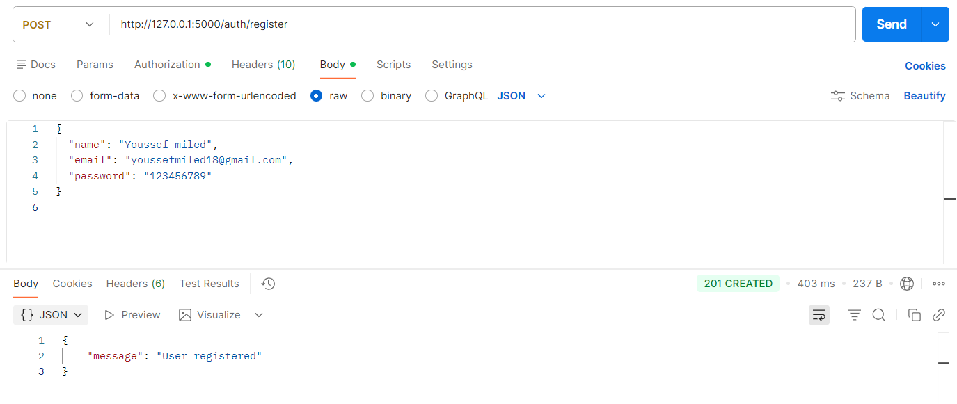
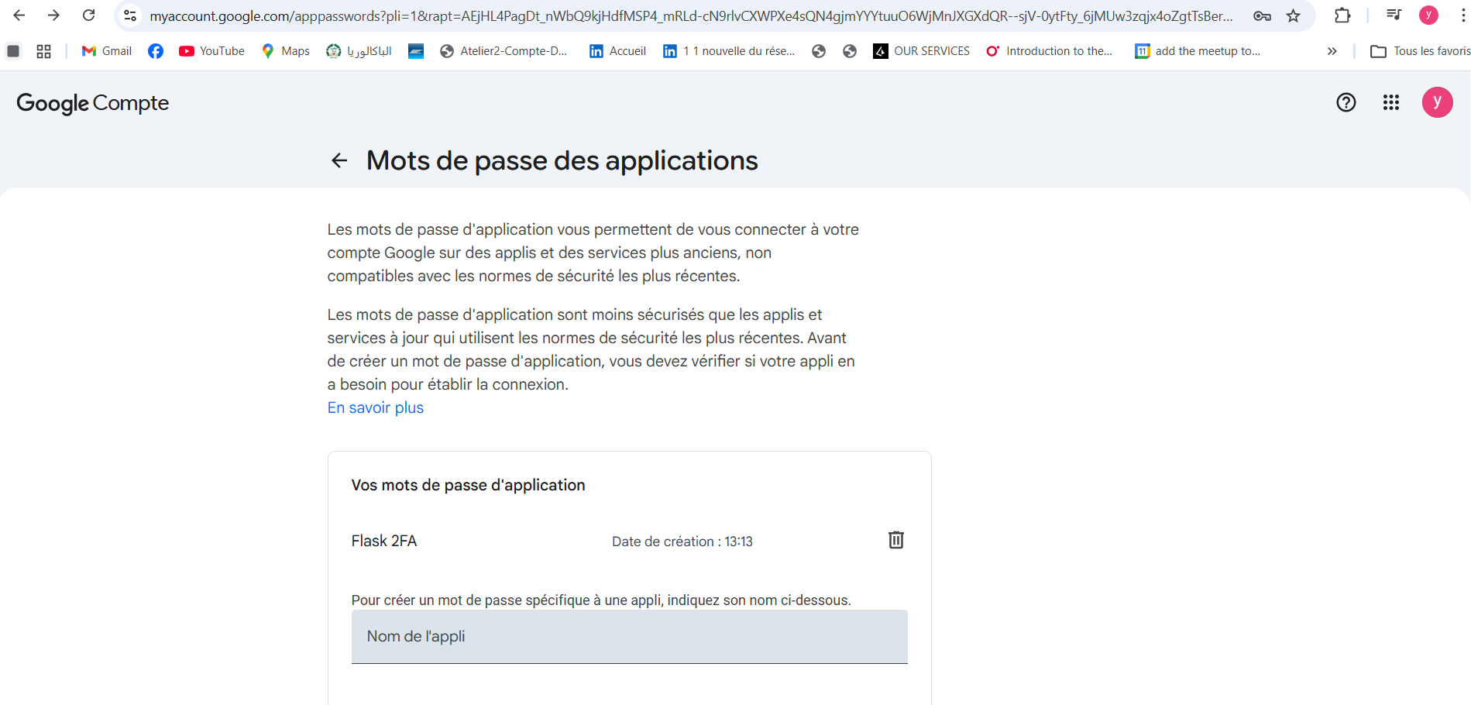
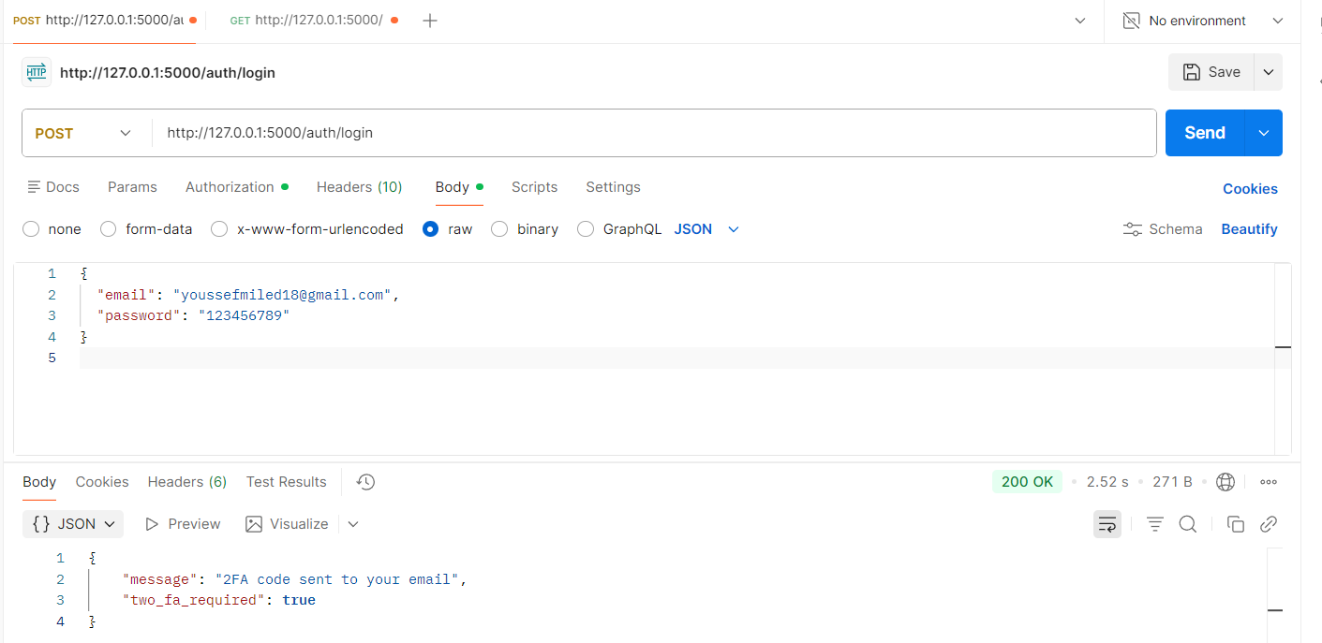
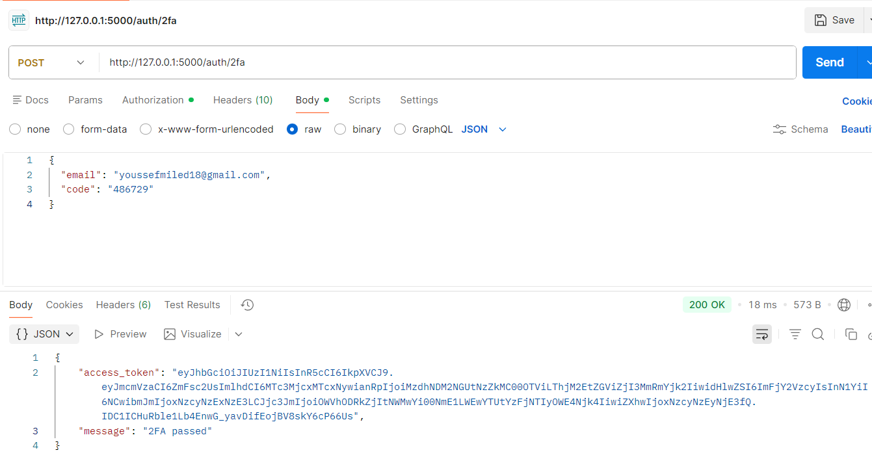
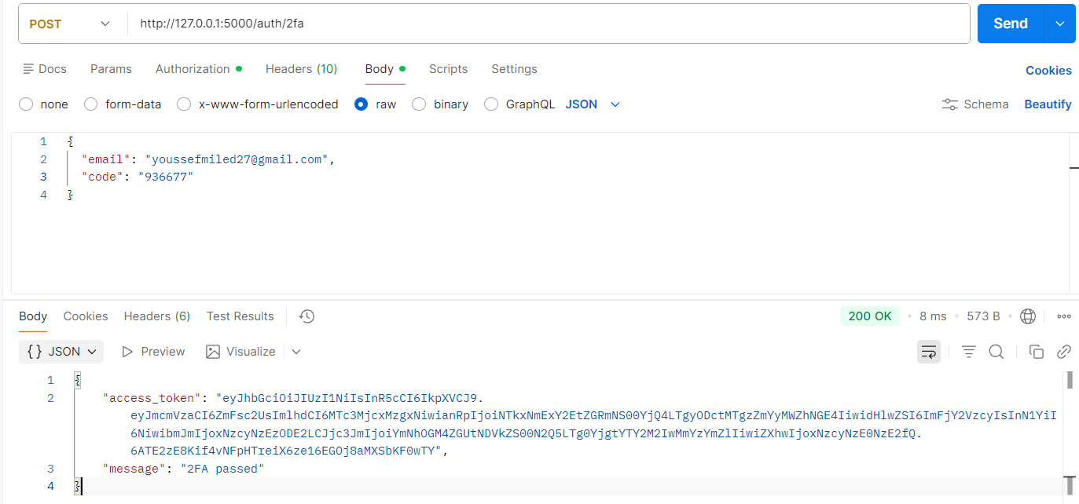
Admin
3️⃣ Tester le login admin via Postman :
- POST http://127.0.0.1:5000/auth/login
- Body JSON :
{
"email": "youssefmiled18@gmail.com",
"password": "admin123"
}
- Tu dois recevoir :
{
"message": "2FA code sent to your email",
"two_fa_required": true
}

4️⃣ Récupérer le code 2FA
- Vérifie l’email de l’admin (youssefmiled18@gmail.com) : tu devrais recevoir un code à 6 chiffres, par exemple 486729.
- Ce code est généré par generate_2fa_code() et envoyé via send_2fa_email().

5️⃣ Vérifier le code 2FA
- Méthode : POST
- URL :
http://127.0.0.1:5000/auth/2fa
- Body JSON :
{
"email": "youssefmiled18@gmail.com",
"code": "486729"
}
Remplace "486729" par le code que tu as reçu dans l’email.
- Réponse attendue :
{
"access_token": "<ton_jwt_token>",
"message": "2FA passed"
}

1️⃣ Tester toutes les routes CRUD
1️⃣ Test CREATE website
Request
POST http://localhost:5000/api/websites
Body (JSON)
{
"name": "Mon Site Test",
"description": "site de test",
"template": "blog",
"primary_color": "#2563EB"
}
Résultat attendu
Status
201 Created
Response
{
"message": "Website created successfully",
"website": {
"id": 1,
"name": "Mon Site Test",
"description": "site de test",
"template": "blog",
"primary_color": "#2563EB"
}
}

2️⃣ Test GET tous les websites
Request
GET http://localhost:5000/api/websites
Résultat attendu
200 OK
Response
[
{
"id": 1,
"name": "Mon Site Test",
"description": "site de test",
"template": "blog",
"primary_color": "#2563EB"
}
]

3️⃣ Test GET website par ID (existant)
Request
GET http://localhost:5000/api/websites/2
4️⃣ Test UPDATE website
Request
PUT http://localhost:5000/api/websites/2
Body
{
"name": "Mon Site Modifié",
"description": "description modifiée",
"primary_color": "#FF0000"
}
5️⃣ Test DELETE website
Request
DELETE http://localhost:5000/api/websites/2
6️⃣ Test GET website supprimé
Request
GET http://localhost:5000/api/websites/2

7️⃣ Test DELETE website inexistant
Request
DELETE http://localhost:5000/api/websites/999
8️⃣ Test POST sans name
Request
POST http://localhost:5000/api/websites
Body
{
"description": "Site sans nom",
"template": "blog",
"primary_color": "#123456"
}
9️⃣ Test UPDATE website inexistant
Request
PUT http://localhost:5000/api/websites/999
Body
{
"name": "Test"
}

